EE3-19 Real Time Digital Signal Processing

Coursework Report 1: Lab 2

Jeremy Chan\*

Department of Electrical and Electronic Engineering

Imperial College

London, United Kingdom

[jc4913@ic.ac.uk](mailto:jc4913@ic.ac.uk) | 00818433

Chak Yeung Dominic Kwok\*

Department of Electrical and Electronic Engineering

Imperial College

London, United Kingdom

[cyk113@ic.ac.uk](mailto:cyk113@ic.ac.uk) | 00827832

\*These authors contributed equally to this work

*Abstract*— This is the first report for E3-19 Real Time Digital Signal Processing’s (2015-2016). The aim is to understand sine wave generation on hardware (lab 2).

# Introduction

A skeleton code for sine wave generation was provided – modifications were made to allow for the generation of a variable frequency sine wave, increase resolution of the lookup table, and to implement a difference equation method instead of the lookup table method. Oscilloscope graphs are shown for multiple frequencies to prove the operation of the code, along with code explanations in both the main text and the appendix.

# Questions

## Provide a trace table of Sinegen for several loops of the code. How many samples does it have to generate to complete a whole cycle?

The trace table, shown in Figure I, was generated by copying the first 20 results to an array. Hence, it takes 8 samples to generate a whole cycle. This can also be found by.

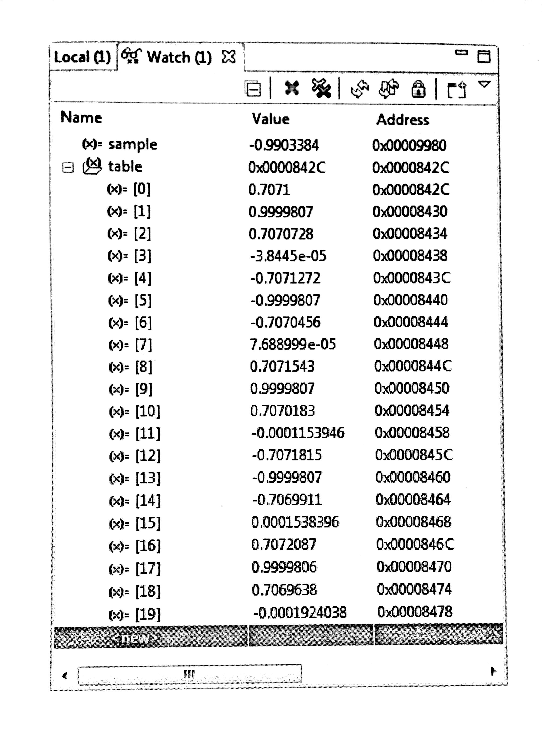

1. Trace Table of the first 20 outputs

## Can you see why the output of the sinewave is currently fixed at 1 kHz? Why does the program not output samples as fast as it can? What hardware throttles it to 1 kHz? (If you are having problems working this out try changing the sampling frequency2 by changing sampling\_freq).

By looking at , and using Appendix 1 of the lab booklet, the sinegen(void) function implements an IIR filter with a transfer function: . Hence, if Therefore, since sampling\_freq is defined as 8000, the output sine\_freq is 1000.

By looking at the code to pass the output samples to the DAC, the program continuously polls the DAC to see if its buffer is empty.

while (!DSK6713\_AIC23\_write(H\_Codec, ((Int32)(sample \* L\_Gain))))

{};

Since the DAC hardware is configured to have a sample rate of 0x008d, hence 8Khz, the DAC buffer will empty once every 125µs.

## By reading through the code can you work out the number of bits used to encode each sample that is sent to the audio port?

void init\_hardware**(),**MCBSP\_FSETS**(**XCR1**,** XWDLEN1**,** 32BIT**);**

shows that the resolution is 32 bits. This also matches the DSK6713\_AIC23\_Config initial setting of 0x004f -> 32 bit.

# Operation of Code

## Initialising the Hardware

void init\_hardware**()** configures the hardware using defined global variables. The struct of the config for configuring the handle can be found in the included header files. This function is executed as the first line of main before any testbench code is executed.

## Main Testbench

The main function first initializes the hardware, enters a while (1) infinite loop that calculates a value for current sine wave coefficient before entering a nested while loop, polling the DAC buffer for write availability. If the DAC is not yet ready (corresponding to the configured DAC sampling frequency), the program will do nothing and try again. The rate of the program trying to ask for write availability depends on the clock speed of the processor running the program.

## Look-up Table Function

A table that consists of the coefficients of a sine wave can be generated by a for loop. Then, to generate a variable sine wave, the program can iterate through this look-up table. To generate a sine wave of a higher frequency, the program can skip values in the look-up table. Care has to be taken regarding the wrapping around of the array index when it is larger than the array size.

The step size can be defined as freq**\***SINE\_TABLE\_SIZE**/**sampling\_freq**;**

#### Modification 1: linear interpolation

The result of the sine wave to be output can be improved slightly by taking the gradient of the current sample [1].

float result **=** **(**iterator**<=**SINE\_TABLE\_SIZE**-**2**)?((**table**[(**int**)**iterator**])** **+** **((**table**[(**int**)(**iterator**+**1**)]** **-** table**[(**int**)**iterator**])/**2**)):(**table**[(**int**)**iterator**]);**

#### Modification 2: Adding resolution to look-up table

The creation of the look-up table involves calculating coefficients for a whole sine wave. Since a sine wave is symmetrical, the look-up table can be improved by only generating a quarter of a sine wave. Extra logic (TABLE I) will then have to be implemented to take into account the current phase, direction of iteration, and whether the current value is positive or negative [2].

|  |  |  |
| --- | --- | --- |
| Quadrant (degrees) | Array Index | Negation |
| 0 – 90 | Index | 0 |
| 90 – 180 | Table size – index | 0 |
| 180 – 270 | Index | 1 |
| 270 - 360 | Table size - index | 1 |

#### Modification 3: Implementing the difference equation instead of the lookup table method



By changing the hardcoded a0 and b0 values, a variable sinewave can be generated without the need for a lookup table.

# Discussion of Results

## Limitation of generated frequencies

The limitation on the upper bound of frequencies that can be generated can be explained using the Nyquist rate – the absolute upper bound on the generated frequency should be .

Since our sine wave is digitally generated, the limit on the digital frequency, k, is from. Around the Nyquist rate (, the generated waveform becomes slightly aliased (Figure 2).

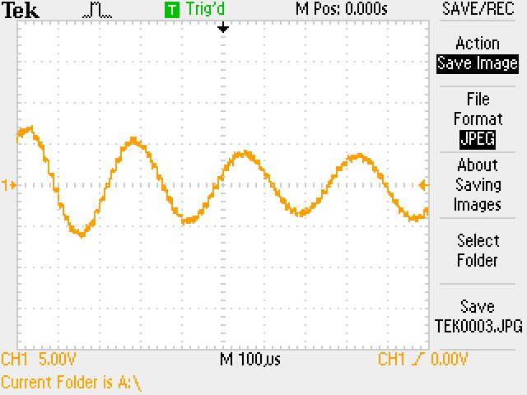

1. 8000Hz sampling frequency /3900Hz sine frequency

However, when the generated frequency is over the Nyquist rate of 4KHz, a visible sine wave appears . This sine wave has a frequency of. For Figure 3, this sine wave was set to be 4500Hz, but measures to be 3500Hz. The filter’s frequency response is in Appendix.B.

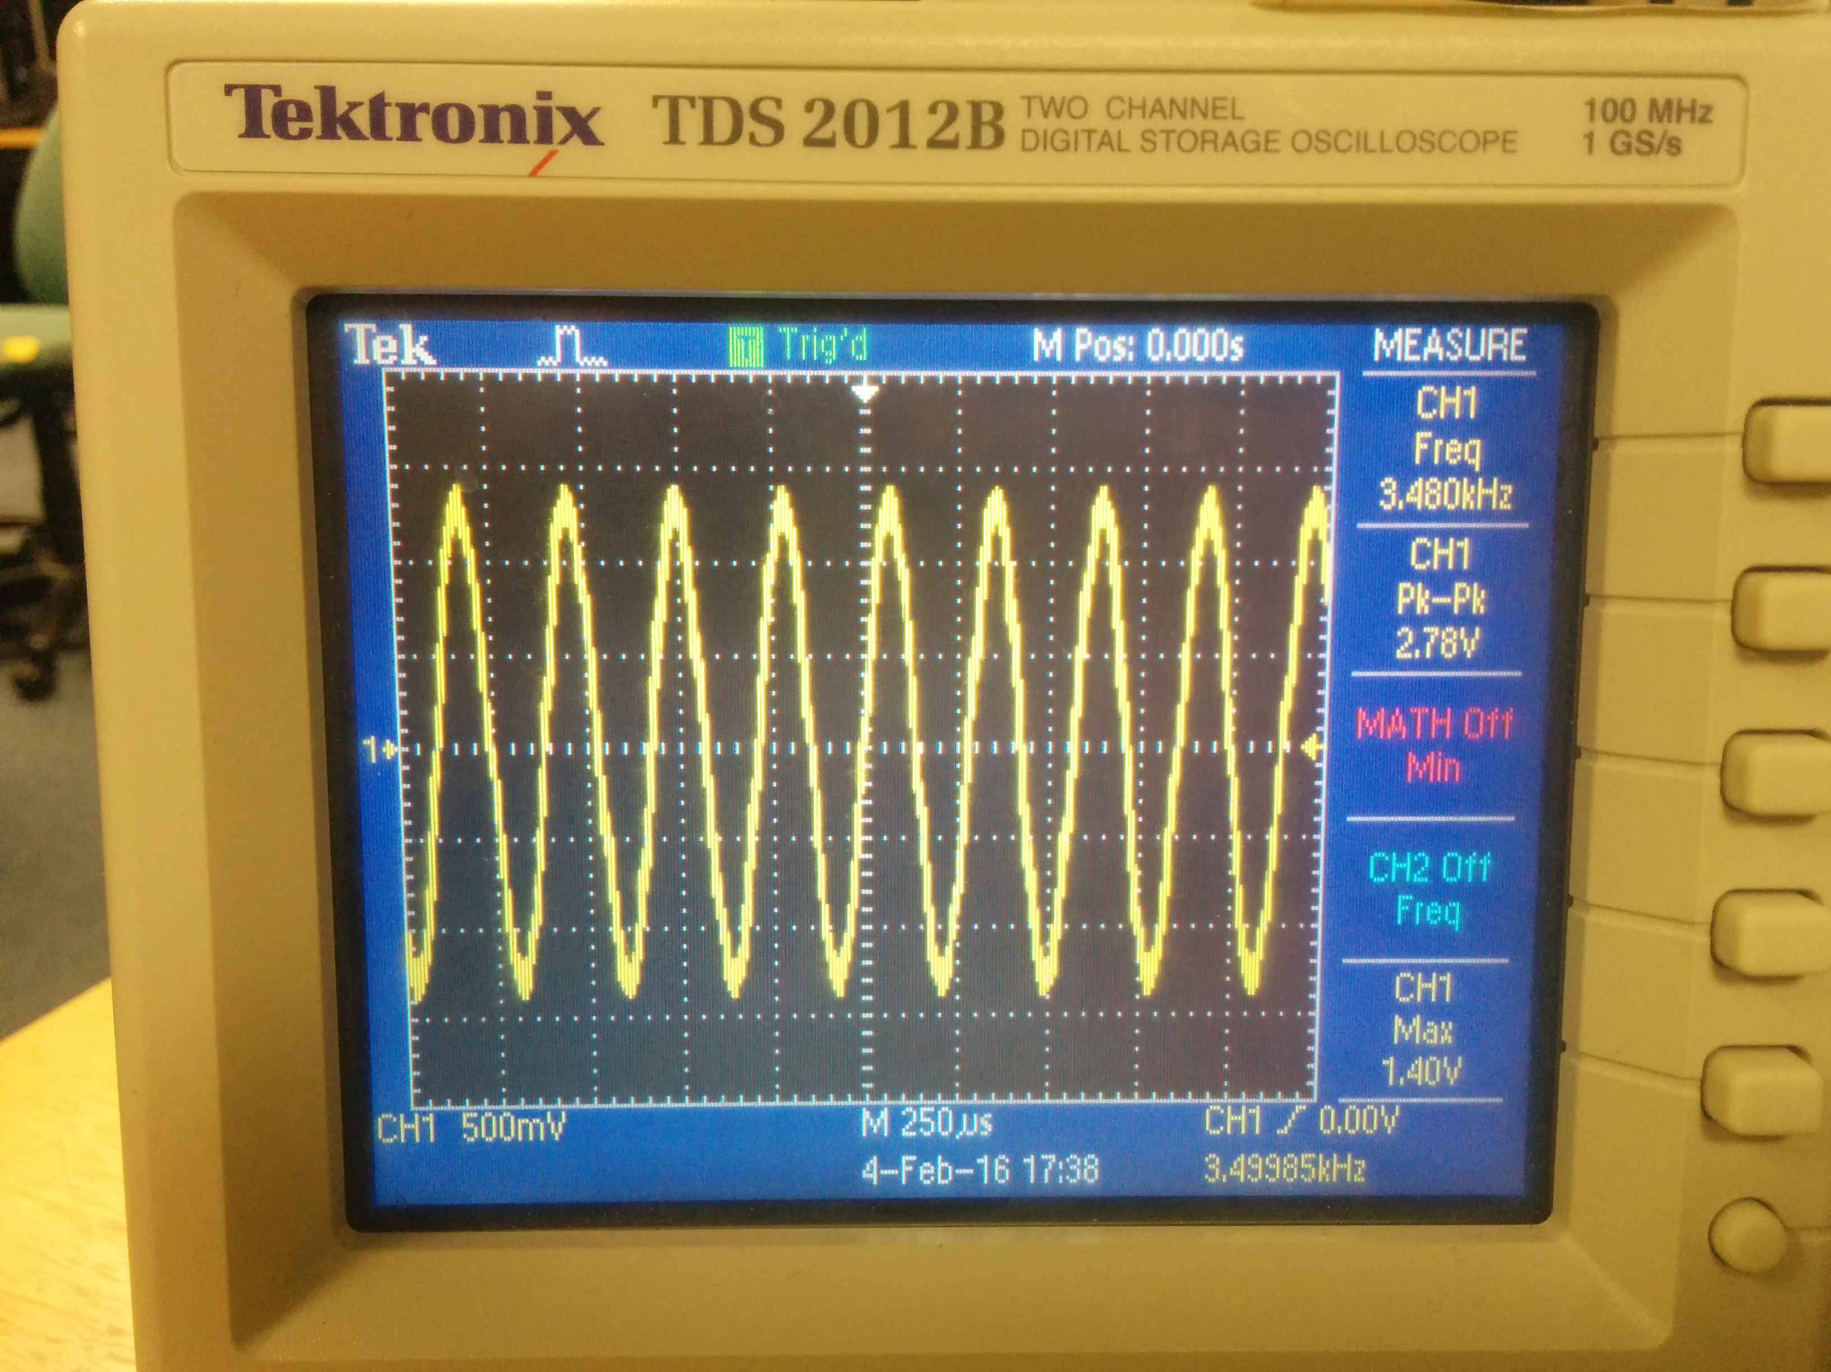

1. Scope showing 4500Hz -> 3500Hz

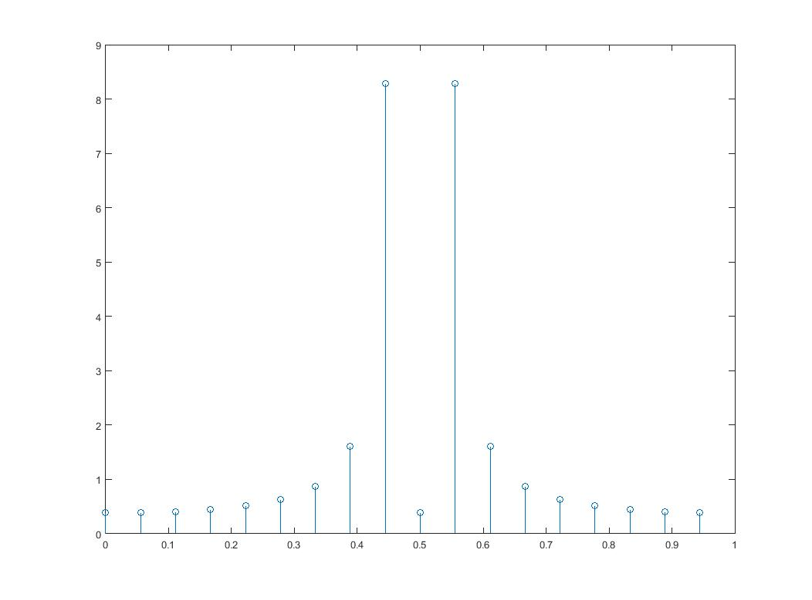

1. 8000Hz sampling frequency /4500Hz sine frequency, pre filter

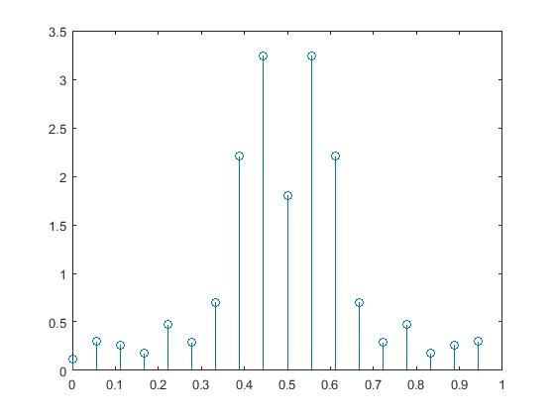

1. 8000Hz sampling frequency /4500Hz sine frequency, post filter

Additionally, there are A.M.-like characteristics when zooming out (Figure 6). By looking at Figure 3-19 of the Texas Instruments AIC23 datasheet (Appendix.A), the low pass filter implementation inside the DAC can be seen. When the output frequency is near the Nyquist frequency, e.g. at 4050Hz, the gain is around 0.5. Therefore, the output of the DAC (Figure 7) is

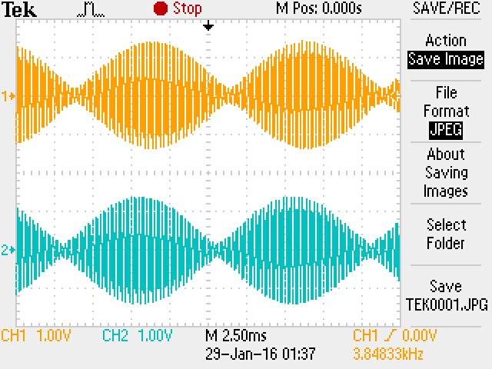

1. AM Characteristics near Nyquist

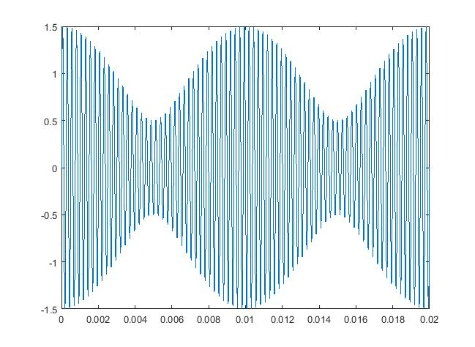

1. Output of DAC (MATLAB)

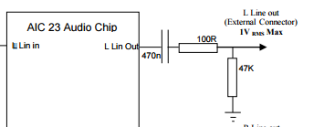

1. Output High Pass Filter of DAC

There is no lower bound on the generated frequency with respect to the code as the step size can be as small as possible – however, by looking at the output stage of the DAC (Figure 8), attenuation can be seen at frequencies lower than 100Hz.

By using MATLAB to plot a Bode plot of the filter (Figure 9), the high pass characteristics can be seen. Hence, there is no lower bound, but only a reduced amplitude when at low frequencies.

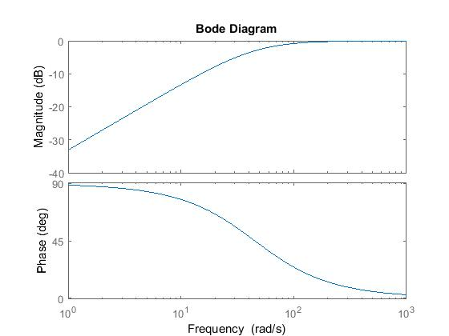

1. Bode Plot of the DAC Output Stage

# Conclusion

This task was completed successfully and improvements were made to improve the output of the generated sine wave.

Further improvements can include pre-computing the lookup table instead of generating it at runtime, and using two lookup tables to further improve the accuracy of the sine wave [2].

# REFERENCES

|  |  |
| --- | --- |
| [1] | R. Bencina, "Ross Bencina," [Online]. Available: http://www.rossbencina.com/code/sinusoids. [Accessed 1 2 2016]. |
| [2] | P. Cheung, "EE3\_DSD," 24 1 2008. [Online]. Available: http://www.ee.ic.ac.uk/pcheung/teaching/ee3\_DSD/Topic%205%20-%20Function%20Evaluation.pdf. [Accessed 1 2 2016]. |

##### Appendix

## Texas Instruments AIC23 Datasheet

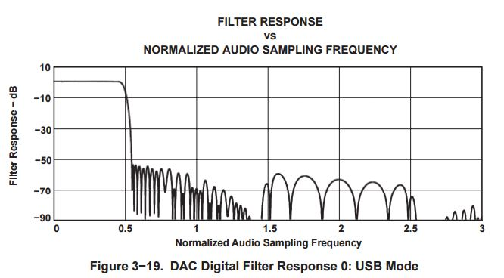

## Oscilloscope Traces (all at 8KHz sampling rate)

|  |
| --- |
|  |
| 10Hz |
| 100Hz |
| C:\Users\Jeremy\AppData\Local\Microsoft\Windows\INetCache\Content.Word\8000fs_1000f.jpg |
| 1000Hz |
| C:\Users\Jeremy\AppData\Local\Microsoft\Windows\INetCache\Content.Word\8000fs_3900f.jpg |
| 3900Hz |

## MATLAB Filter Frequency Response

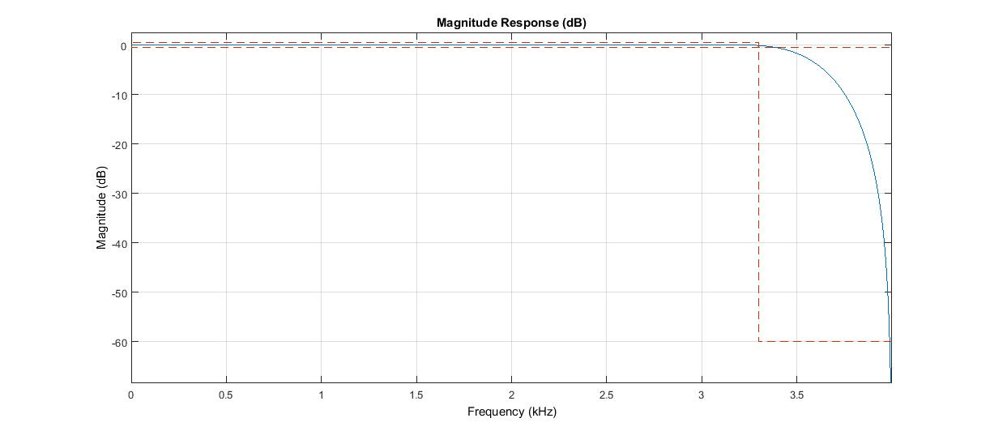

## 

## Code

/\*\*\*\*\*\*\*\*\*\*\*\*\*\*\*\*\*\*\*\*\*\*\*\*\*\*\*\*\*\*\*\*\*\*\*\*\*\*\*\*\*\*\*\*\*\*\*\*\*\*\*\*\*\*\*\*\*\*\*\*\*\*\*\*\*\*\*\*\*\*\*\*\*\*\*\*\*\*\*\*\*\*\*\*\*

DEPARTMENT OF ELECTRICAL AND ELECTRONIC ENGINEERING

IMPERIAL COLLEGE LONDON

EE 3.19: Real Time Digital Signal Processing

Dr Paul Mitcheson and Daniel Harvey

LAB 2: Learning C and Sinewave Generation

\*\*\*\*\*\*\*\*\* S I N E . C \*\*\*\*\*\*\*\*\*\*

Demonstrates outputing data from the DSK's audio port.

Used for extending knowledge of C and using look up tables.

\*\*\*\*\*\*\*\*\*\*\*\*\*\*\*\*\*\*\*\*\*\*\*\*\*\*\*\*\*\*\*\*\*\*\*\*\*\*\*\*\*\*\*\*\*\*\*\*\*\*\*\*\*\*\*\*\*\*\*\*\*\*\*\*\*\*\*\*\*\*\*\*\*\*\*\*\*\*\*\*\*\*\*\*\*

Updated for use on 6713 DSK by Danny Harvey: May-Aug 06/Dec 07/Oct 09

CCS V4 updates Sept 10

\*\*\*\*\*\*\*\*\*\*\*\*\*\*\*\*\*\*\*\*\*\*\*\*\*\*\*\*\*\*\*\*\*\*\*\*\*\*\*\*\*\*\*\*\*\*\*\*\*\*\*\*\*\*\*\*\*\*\*\*\*\*\*\*\*\*\*\*\*\*\*\*\*\*\*\*\*\*\*\*\*\*\*\*/

/\*

\* Initialy this example uses the AIC23 codec module of the 6713 DSK Board Support

\* Library to generate a 1KHz sine wave using a simple digital filter.

\* You should modify the code to generate a sine of variable frequency.

\*/

/\*\*\*\*\*\*\*\*\*\*\*\*\*\*\*\*\*\*\*\*\*\*\*\*\*\*\*\* Pre-processor statements \*\*\*\*\*\*\*\*\*\*\*\*\*\*\*\*\*\*\*\*\*\*\*\*\*\*\*\*\*\*/

// Included so program can make use of DSP/BIOS configuration tool.

#include "dsp\_bios\_cfg.h"

/\* The file dsk6713.h must be included in every program that uses the BSL. This

example also includes dsk6713\_aic23.h because it uses the

AIC23 codec module (audio interface). \*/

#include "dsk6713.h"

#include "dsk6713\_aic23.h"

// math library (trig functions)

#include <math.h>

#include<stdlib.h>

// Some functions to help with configuring hardware

#include "helper\_functions\_polling.h"

// PI defined here for use in your code

#define PI 3.141592653589793

#define SINE\_TABLE\_SIZE 256

/\*\*\*\*\*\*\*\*\*\*\*\*\*\*\*\*\*\*\*\*\*\*\*\*\*\*\*\*\*\*\* Global declarations \*\*\*\*\*\*\*\*\*\*\*\*\*\*\*\*\*\*\*\*\*\*\*\*\*\*\*\*\*\*\*\*/

/\* Audio port configuration settings: these values set registers in the AIC23 audio

interface to configure it. See TI doc SLWS106D 3-3 to 3-10 for more info. \*/

DSK6713\_AIC23\_Config Config **=** **{** \

/\*\*\*\*\*\*\*\*\*\*\*\*\*\*\*\*\*\*\*\*\*\*\*\*\*\*\*\*\*\*\*\*\*\*\*\*\*\*\*\*\*\*\*\*\*\*\*\*\*\*\*\*\*\*\*\*\*\*\*\*\*\*\*\*\*\*\*\*\*\*/

/\* REGISTER FUNCTION SETTINGS \*/

/\*\*\*\*\*\*\*\*\*\*\*\*\*\*\*\*\*\*\*\*\*\*\*\*\*\*\*\*\*\*\*\*\*\*\*\*\*\*\*\*\*\*\*\*\*\*\*\*\*\*\*\*\*\*\*\*\*\*\*\*\*\*\*\*\*\*\*\*\*\*/\

0x0017**,** /\* 0 LEFTINVOL Left line input channel volume 0dB \*/\

0x0017**,** /\* 1 RIGHTINVOL Right line input channel volume 0dB \*/\

0x01f9**,** /\* 2 LEFTHPVOL Left channel headphone volume 0dB \*/\

0x01f9**,** /\* 3 RIGHTHPVOL Right channel headphone volume 0dB \*/\

0x0011**,** /\* 4 ANAPATH Analog audio path control DAC on, Mic boost 20dB\*/\

0x0000**,** /\* 5 DIGPATH Digital audio path control All Filters off \*/\

0x0000**,** /\* 6 DPOWERDOWN Power down control All Hardware on \*/\

0x004f**,** /\* 7 DIGIF Digital audio interface format 32 bit \*/\

0x008d**,** /\* 8 SAMPLERATE Sample rate control 8 KHZ \*/\

0x0001 /\* 9 DIGACT Digital interface activation On \*/\

/\*\*\*\*\*\*\*\*\*\*\*\*\*\*\*\*\*\*\*\*\*\*\*\*\*\*\*\*\*\*\*\*\*\*\*\*\*\*\*\*\*\*\*\*\*\*\*\*\*\*\*\*\*\*\*\*\*\*\*\*\*\*\*\*\*\*\*\*\*\*/

**};**

// Codec handle:- a variable used to identify audio interface

DSK6713\_AIC23\_CodecHandle H\_Codec**;**

/\* Sampling frequency in HZ. Must only be set to 8000, 16000, 24000

32000, 44100 (CD standard), 48000 or 96000 \*/

int sampling\_freq **=** 8000**;**

// Array of data used by sinegen to generate sine. These are the initial values.

float y**[**3**]** **=** **{**0**,**0**,**0**};**

float x**[**1**]** **=** **{**1**};** // impulse to start filter

float a0 **=** 1.4142**;** // coefficients for difference equation

float b0 **=** 0.707**;**

// Holds the value of the current sample

float sample**;**

float sample2**;**

float table**[**SINE\_TABLE\_SIZE**]={**0**};**

float table3**[**SINE\_TABLE\_SIZE**]={**0**};**

void sine\_init**(**void**);**

/\* Left and right audio channel gain values, calculated to be less than signed 32 bit

maximum value. \*/

Int32 L\_Gain **=** 2100000000**;**

Int32 R\_Gain **=** 2100000000**;**

/\* Use this variable in your code to set the frequency of your sine wave

be carefull that you do not set it above the current nyquist frequency! \*/

float sine\_freq **=** 3950.0**;**

float sinegen2**(**float**\*** table**,** int freq**);**

float sinegen3**(**float**\*** table**,** float freq**);**

/\*\*\*\*\*\*\*\*\*\*\*\*\*\*\*\*\*\*\*\*\*\*\*\*\*\*\*\*\*\*\* Function prototypes \*\*\*\*\*\*\*\*\*\*\*\*\*\*\*\*\*\*\*\*\*\*\*\*\*\*\*\*\*\*\*\*/

void init\_hardware**(**void**);**

float sinegen**(**void**);**

void sine3\_init**(**void**);**

/\*\*\*\*\*\*\*\*\*\*\*\*\*\*\*\*\*\*\*\*\*\*\*\*\*\*\*\*\*\*\*\*\*\* Main routine \*\*\*\*\*\*\*\*\*\*\*\*\*\*\*\*\*\*\*\*\*\*\*\*\*\*\*\*\*\*\*\*\*\*\*\*/

void main**()**

**{**

// initialize board and the audio port

init\_hardware**();**

sine\_init**();**

sine3\_init**();**

// Loop endlessley generating a sine wave

**while(**1**)**

**{**

// Calculate next sample

sample **=** sinegen2**(**table**,(**int**)**sine\_freq**);**

sample2 **=** sinegen3**(**table3**,**sine\_freq**);**

//sample2=sinegen();

/\* Send a sample to the audio port if it is ready to transmit.

Note: DSK6713\_AIC23\_write() returns false if the port if is not ready \*/

// send to LEFT channel (poll until ready)

**while** **(!**DSK6713\_AIC23\_write**(**H\_Codec**,** **((**Int32**)(**sample **\*** L\_Gain**))))**

**{};**

// send same sample to RIGHT channel (poll until ready)

**while** **(!**DSK6713\_AIC23\_write**(**H\_Codec**,** **((**Int32**)(**sample2 **\*** R\_Gain**))))**

**{};**

// Set the sampling frequency. This function updates the frequency only if it

// has changed. Frequency set must be one of the supported sampling freq.

set\_samp\_freq**(&**sampling\_freq**,** Config**,** **&**H\_Codec**);**

**}**

**}**

/\*\*\*\*\*\*\*\*\*\*\*\*\*\*\*\*\*\*\*\*\*\*\*\*\*\*\*\*\*\*\* init\_hardware() \*\*\*\*\*\*\*\*\*\*\*\*\*\*\*\*\*\*\*\*\*\*\*\*\*\*\*\*\*\*\*\*\*\*\*\*/

void init\_hardware**()**

**{**

// Initialize the board support library, must be called first

DSK6713\_init**();**

// Start the codec using the settings defined above in config

H\_Codec **=** DSK6713\_AIC23\_openCodec**(**0**,** **&**Config**);**

/\* Defines number of bits in word used by MSBSP for communications with AIC23

NOTE: this must match the bit resolution set in in the AIC23 \*/

MCBSP\_FSETS**(**XCR1**,** XWDLEN1**,** 32BIT**);**

/\* Set the sampling frequency of the audio port. Must only be set to a supported

frequency (8000/16000/24000/32000/44100/48000/96000) \*/

DSK6713\_AIC23\_setFreq**(**H\_Codec**,** get\_sampling\_handle**(&**sampling\_freq**));**

**}**

/\*\*\*\*\*\*\*\*\*\*\*\*\*\*\*\*\*\*\*\*\*\*\*\*\*\*\*\*\*\*\*\*\*\* sinegen() \*\*\*\*\*\*\*\*\*\*\*\*\*\*\*\*\*\*\*\*\*\*\*\*\*\*\*\*\*\*\*\*\*\*\*\*\*\*\*/

float sinegen**(**void**)**

**{**

/\* This code produces a fixed sine of 1KHZ (if the sampling frequency is 8KHZ)

using a digital filter.

You will need to re-write this function to produce a sine of variable frequency

using a look up table instead of a filter.\*/

// temporary variable used to output values from function

float wave**;**

// represets the filter coeficients (square root of 2 and 1/square root of 2)

float a0 **=** 2**\***cos**(**2**\***PI**\***sine\_freq**/**sampling\_freq**);**

float b0 **=** sin**(**2**\***PI**\***sine\_freq**/**sampling\_freq**);**

y**[**0**]** **=** a0 **\*** y**[**1**]** **-** y**[**2**]** **+** b0 **\*** x**[**0**];** // Difference equation

y**[**2**]** **=** y**[**1**];** // move values through buffer

y**[**1**]** **=** y**[**0**];**

x**[**0**]** **=** 0**;** // reset input to zero (to create the impulse)

wave **=** y**[**0**];**

**return(**wave**);**

**}**

void sine\_init**(**void**){**

int i**=**0**;**

**for** **(**i**=**0**;**i**<** SINE\_TABLE\_SIZE**;**i**++){**

table**[**i**]=**sin**(**2**\***PI**\***i**/**SINE\_TABLE\_SIZE**);**

**}**

**}**

void sine3\_init**(**void**){**

int i**=**0**;**

**for** **(**i**=**0**;**i**<** SINE\_TABLE\_SIZE**;**i**++){**

table3**[**i**]=**sin**(**PI**\***0.5**\***i**/**SINE\_TABLE\_SIZE**);**

**}**

**}**

float sinegen2**(**float**\*** table**,** float f**){**

static float iterator **=** 0**;**

//use linear iterpolation between next value to get an average

float result **=** **(**iterator**<=**SINE\_TABLE\_SIZE**-**2**)?((**table**[(**int**)**iterator**])** **+** **((**table**[(**int**)(**iterator**+**1**)]** **-** table**[(**int**)**iterator**])/**2**)):(**table**[(**int**)**iterator**]);**

iterator **+=** f**\*(** SINE\_TABLE\_SIZE **)/**sampling\_freq**;**

**if** **(**iterator **>** SINE\_TABLE\_SIZE**)** **{**iterator **-=** SINE\_TABLE\_SIZE**;}**

**return** result**;**

**}**

float sinegen3**(**float**\*** table**,** float freq**){**

float step**=** 360.00**\*((**float**)** freq**/(**float**)**sampling\_freq**);**

static float phase**=**0**;**

float result**=**0**;**

**if(**phase**<**90**){**

result**=**table**[(**int**)((**phase**/**90.0**)\***SINE\_TABLE\_SIZE**)];**

**}**

**if(**phase**<**180**&&**phase**>**90**){**

result**=**table**[**SINE\_TABLE\_SIZE**-(**int**)(((**phase**-**90**)/**90.0**)\***SINE\_TABLE\_SIZE**)];**

**}**

**if(**phase**<**270**&&**phase**>**180**){**

result**=-**table**[(**int**)(((**phase**-**180.0**)/**90.0**)\***SINE\_TABLE\_SIZE**)];**

**}**

**if(**phase**<**360**&&**phase**>**270**){**

result**=-**table**[**SINE\_TABLE\_SIZE**-(**int**)(((**phase**-**270**)/**90.0**)\***SINE\_TABLE\_SIZE**)];**

**}**

**if(**phase**==**90**)**

result**=**table**[**SINE\_TABLE\_SIZE**-**1**];**

**if(**phase**==**270**)**

result**=-**table**[**SINE\_TABLE\_SIZE**-**1**];**

**if(**phase**==**360**||**phase**==**180**)**

result**=**table**[**0**];**

phase**+=**step**;**

**if(**phase**>=**360**){**

phase**=**phase**-**360**;**

**}**

**return** result**;**

**}**